c3-JAW, 4-JAW & 6 JAW STANDARD SELF CENTRING CHUCKS
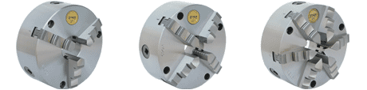
STC-3 | STC-4 | STC-6
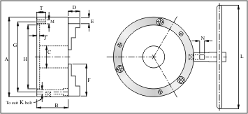
These chucks are available with 3 jaws, 4 jaws and 6 jaws and are referred as STC-3, STC-4 and STC-6 respectively. STC-3 chucks are most popular. STC-4 chucks are used when the job is square. STC-6 chucks are used to grip jobs having thin walls as holding pressure is divided on six sides. One set of reverse Jaws, Mounting Bolts, Operating Key and Inspection Report is provided with each chuck
*Product  Code | Size  in mm | A | B | C | D | E | F | G | H | J | K/M | L | N | T
  WEIGHT IN KGS
  (APPROX.)
  3 JAW | 4 JAW | 6 JAW
1001-603 | 60 | 62 | 40 | 11 | 11 | 9.4 | 24 | 51.5 | 43 | 2.5 | M5 | 140 | 6 | 12 | 0.9 | -- | --
1001-803 | 80 | 83 | 45 | 19 | 13 | 12 | 29 | 71.3 | 63.5 | 3 | M5 | 140 | 6 | 12 | 2.1 | 2.2 | --
1001-1003 | 100 | 103 | 52 | 26 | 17 | 15 | 37 | 89 | 76.2 | 3 | M6 | 175 | 8 | 12 | 3.3 | 3.4 | 3.8
1001-1253 | 125 | 125 | 55 | 35 | 19 | 16 | 45 | 108 | 95 | 4 | M8 | 175 | 8 | 15 | 4.4 | 4.5 | 4.9
1001-1603 | 160 | 160 | 70 | 42 | 24 | 20 | 65 | 140 | 125 | 6 | M10 | 215 | 10 | 20 | 9.2 | 9.6 | 10.7
1001-2003 | 200 | 200 | 78 | 55 | 29 | 22 | 80 | 176 | 160 | 7 | M10 | 285 | 12 | 22 | 15.6 | 16.2 | 17.8
1001-2303 | 230 | 230 | 78 | 70 | 29 | 22 | 80 | 205 | 180 | 7 | M10 | 285 | 12 | 22 | 21.1 | 22.0 | 24.0
1001-2503 | 250 | 250 | 86 | 76 | 35 | 29 | 95 | 224 | 200 | 7 | M12 | 315 | 13 | 25 | 26.2 | 27.5 | 30.4
1001-2703 | 270 | 270 | 86 | 90 | 35 | 29 | 95 | 245 | 220 | 7 | M12 | 315 | 13 | 25 | 29.0 | 30.2 | 33
1001-3153 | 315 | 315 | 88 | 105 | 42 | 32 | 109 | 286 | 260 | 7 | M12 | 350 | 14 | 25 | 40.5 | 42.4 | 46.5
1001-4003 | 400 | 400 | 95 | 140 | 50 | 38 | 141 | 362 | 330 | 7 | M16 | 450 | 16 | 32 | 73.5 | 75.7 | 83.8
1001-5003 | 500 | 500 | 110 | 190 | 57 | 45 | 160 | 458 | 420 | 7 | M16 | 520 | 18 | 32 | 120.0 | 125.0 | 135.0
1001-6003 | 600 | 600 | 110 | 260 | 57 | 45 | 160 | 558 | 520 | 7 | M16 | 620 | 18 | 32 | 160.0 | 165.0 | 175.0

2-Jaw, 3-Jaw, 4-Jaw & 6-Jaw Master Grip Chucks
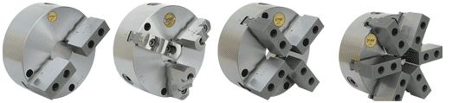
These chucks are available with 2 jaws, 3 jaws, 4 jaws and 6 jaws and are referred as MGC-2, MGC-3, MGC-4 and MGC-6 respectively. The Jaws are made in two portions. There is one threaded base which is hardened. One set of reversible hard top and one set of soft jaw is provided with each chuck. These top jaws are tightened on the base with allen bolts. The advantage of these chucks is that special type of jaws can be made at user's end to suit any type of job which is not possible with normal jaws. Mounting Bolts, Allen Key, Operating Key and Inspection Report is provided with each chuck.
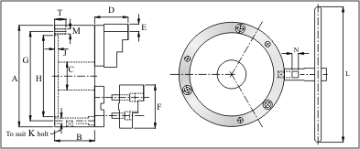
*Product  Code | Size  in mm | A | B | C | D | E | F | G | H | J | K/M | L | N | T
  WEIGHT IN KGS
  (APPROX.)
  2 JAW | 3 JAW | 4 JAW | 6 JAW
1006-803 | 80 | 83 | 45 | 19 | 22 | 16 | 33 | 71.3 | 63.5 | 3 | M5 | 140 | 6 | 12 | 2.1 | 2.3 | -- | --
1006-1003 | 100 | 103 | 52 | 26 | 30 | 22 | 42 | 89 | 76.2 | 3 | M6 | 175 | 8 | 12 | 3.3 | 3.6 | 3.8 | --
1006-1253 | 125 | 125 | 55 | 35 | 37 | 22 | 50 | 108 | 95 | 4 | M8 | 175 | 8 | 15 | 4.4 | 4.7 | 4.9 | --
1006-1603 | 160 | 160 | 70 | 42 | 44 | 28.8 | 72 | 140 | 125 | 6 | M10 | 215 | 10 | 20 | 10 | 10.6 | 11.5 | 13.1
1006-2003 | 200 | 200 | 78 | 55 | 49 | 30.5 | 85 | 176 | 160 | 7 | M10 | 285 | 12 | 22 | 16.2 | 17.2 | 18.4 | 21.0
1006-2303 | 230 | 230 | 78 | 70 | 49 | 30.5 | 85 | 205 | 180 | 7 | M10 | 285 | 12 | 22 | 21.7 | 22.7 | 24.2 | 27.2
1006-2503 | 250 | 250 | 86 | 76 | 51 | 30.5 | 102 | 224 | 200 | 7 | M12 | 315 | 13 | 25 | 27.1 | 28.1 | 30.0 | 34.2
1006-2703 | 270 | 270 | 86 | 90 | 51 | 30.5 | 102 | 245 | 220 | 7 | M12 | 315 | 13 | 25 | 29.8 | 30.9 | 32.7 | 36.8
1006-3153 | 315 | 315 | 88 | 105 | 56 | 35.25 | 116 | 286 | 260 | 7 | M12 | 350 | 14 | 25 | 41.5 | 43.1 | 45.8 | 52.2
1006-4003 | 400 | 400 | 95 | 140 | 70 | 42 | 150 | 362 | 330 | 7 | M16 | 450 | 16 | 32 | 74.5 | 77.0 | 80.7 | 90.0
1006-5003 | 500 | 500 | 110 | 190 | 75 | 50 | 170 | 458 | 420 | 7 | M16 | 520 | 18 | 32 | 122.0 | 126.0 | 133.0 | 146.0
1006-6003 | 600 | 600 | 110 | 260 | 75 | 50 | 170 | 558 | 520 | 7 | M16 | 620 | 18 | 32 | 162.0 | 166.0 | 173.0 | 186.0

3-JAW & 6-JAW ACCURACY ADJUSTMENT CHUCKS

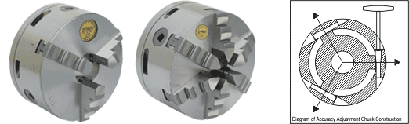
These chucks are available with 3 jaws and 6 jaws and are referred as AAC-3 and AAC-6 respectively. These are used where same size of job is to be held repeatedly and accuracy desired is very high. The chuck accuracy can be adjusted within 0.005 mm with the help of micro-adjustment screws. The repetitive accuracy available with these type of chucks is within 0.013 mm. These chucks are used for tool room and grinding shop work. One set of reverse Jaws, Mounting Bolts, Allen Key, Operating Key and Inspection Report is provided with each chuck.
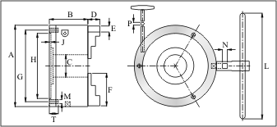
*Product  Code | Size  in mm | A | B | C | D | E | F | G | H | J | M | L | N | T | P
  WEIGHT IN KGS
  (APPROX.)
  3 JAW | 6 JAW
1008-803 | 80 | 83 | 55 | 19 | 13 | 12 | 29 | 71.3 | 63.5 | 3 | M5 | 140 | 6 | 12 | 4 | 2.0 | --
1008-1003 | 100 | 103 | 65 | 26 | 17 | 15 | 37 | 89 | 76.2 | 3 | M6 | 175 | 8 | 12 | 5 | 3.9 | --
1008-1253 | 125 | 125 | 68 | 35 | 19 | 16 | 45 | 108 | 95 | 4 | M8 | 175 | 8 | 15 | 5 | 5.5 | 6.2
1008-1603 | 160 | 160 | 86 | 42 | 24 | 20 | 65 | 140 | 125 | 4 | M10 | 215 | 10 | 20 | 6 | 10.4 | 13
1008-2003 | 200 | 200 | 94 | 55 | 29 | 22 | 80 | 176 | 160 | 4 | M10 | 285 | 12 | 22 | 6 | 17 | 21
1008-2503 | 250 | 250 | 106 | 76 | 35 | 29 | 95 | 224 | 200 | 5 | M12 | 315 | 13 | 25 | 6 | 28 | 34
1008-3153 | 315 | 315 | 108 | 105 | 42 | 32 | 109 | 286 | 260 | 5 | M12 | 350 | 14 | 25 | 8 | 43 | 52

3-JAW LEVER OPERATED SCROLL CHUCKS
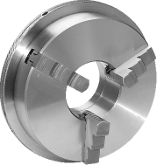 |  | This chuck is available with 3 jaws and is referred as LOC-3. This is light weight lever operated chuck is specially designed for use by craftsmen on instruments, watchmaker’s lathe, bench lathes, grinding machines as well as on small sized machine tools. The body of this chuck is made out of SG Iron to avoid breakage due to slim design of body. The grip of these chucks is limited as the design is without gearing. However this feature has advantage also. The sensitive movement avoids the danger of crushing and have great versatility for gripping fragile materials and components.  Knurled ring, which operates the jaws, give ample grip for light work when hand operated, but a lever is provided for use where a stronger grip is required.
LOC-3

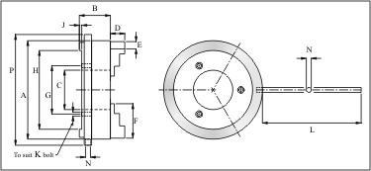

*Product  Code | Size  in mm | A | P | B | C | D | E | F | G | H | J | K | L | N
  WEIGHT
  IN KGS
  (APPROX)
1010-803 | 80 | 83 | 89 | 34.5 | 15.7 | 13 | 12 | 29 | 27.2 | 40 | 2 | M5 | 100 | 8 | 1.25
1010-1003 | 100 | 103 | 110 | 38.5 | 31.7 | 17 | 15 | 37 | 43.2 | 56 | 2 | M5 | 100 | 8 | 2.50
1010-1253 | 125 | 125 | 136 | 46 | 42 | 19 | 16 | 45 | 56 | 70 | 3 | M6 | 150 | 10 | 4.00
1010-1603 | 160 | 160 | 180 | 53 | 52 | 24 | 20 | 65 | 66 | 125 | 5 | M6 | 200 | 10 | 7.00
1010-2003 | 200 | 200 | 225 | 63 | 80 | 29 | 22 | 80 | 98 | 160 | 5 | M8 | 200 | 10 | 10.00

6-JAW DRILL POINT GRINDER CHUCKS
6-Jaw Drill Poin Grinder Chucks
This chuck is available with 6 jaws and is referred as DPG-6. This chuck is specially designed to grip drills for sharpening purpose. Mounting Bolts, Operating Key and Inspection Report is provided with each chuck
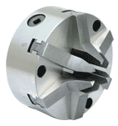 | 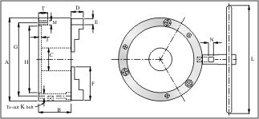
DPG-6

*Product  Code | Size  in mm | A | B | C | D | E | F | G | H | J | K/M | L | N | T
  WEIGHT
  IN KGS
  (APPROX.)
1009-1006 | 100 | 103 | 52 | 26 | 37 | 12 | 37 | 89 | 76.2 | 3 | M6 | 175 | 8 | 12 | 3.2
1009-1256 | 125 | 125 | 55 | 42 | 42 | 16 | 45 | 108 | 95 | 4 | M8 | 175 | 8 | 15 | 5.0
1009-1606 | 160 | 160 | 65 | 52 | 52 | 19 | 65 | 140 | 125 | 4 | M10 | 200 | 10 | 20 | 9.0

EXTRA LIGHT DUTY 4-JAW INDEPENDENT CHUCKS
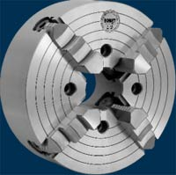
CSV Extra Light Duty Chucks referred as ELD, have been designed specially for use on small precision machines which are light in weight and where chuck weight is critical for the machine. The bodies of 80mm and 100mm chucks are made out of steel and above 100mm from SG Iron. This property of being light weight helps to retain the precision of the bearings of the machine for long time. The vibrations are reduced to the minimum. Used within the capacity, these chucks are sturdy and reliable. Operating Key, Mounting Bolts, Allen Key, Tap & Inspection Report is provided with each chuck.

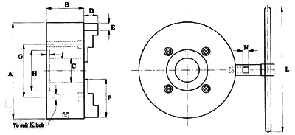
*Product  Code | SIZE | A | B | C | D | E | F | G | H | J | K | L | N | Wt. in Kgs.  Approx.
5191-3 | 3" | 82 | 35 | 19 | 16 | 12 | 35 | 60 | 70 | 2.5 | M6 | 100 | 5 | 1.5
5191-4 | 4" | 101 | 35 | 25.4 | 16 | 12 | 35 | 76.2 | 88.9 | 2.5 | M8 | 115 | 5 | 2
5291-5 | 5" | 130 | 45 | 25.4 | 20 | 15.7 | 51 | 60 | 70 | 3 | M8 | 165 | 7 | 3.5
5291-6 | 6" | 152 | 45 | 40 | 20 | 15.7 | 51 | 69.8 | 82.5 | 3 | M8 | 165 | 7 | 4.5
5291-8 | 8" | 203 | 50 | 45 | 24 | 19 | 63 | 82.5 | 95.25 | 3.5 | M10 | 215 | 7.5 | 8.5
5291-10 | 10" | 254 | 69 | 50 | 29 | 25.4 | 83 | 111 | 127 | 5 | M10 | 265 | 9 | 18.8

EXTRA HEAVY DUTY 4 JAW INDEPENDENT CHUCKS
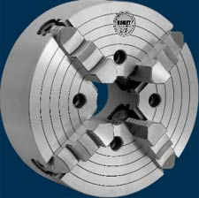
CSV Extra Heavy Duty chucks refereed as EHD are manufactured to cope with toughest working conditions. These are capable of carrying heavy loads. The height of bodies though little more, but it helps not break under the loads. The jaw-ways in body are of robust proportion which can withstand heavy loads. The diameter of screws is large enough to tolerate heavy cutting pressure and moreover large diameter of screws provide more contact area with thread of jaws. ACME threads of screws are very strong as the same have 29 degree taper. These do not break easily due to strength provided by large base of taper thread. Alloy steel having Nickel, Chromium and Molybdnem is used in the manufacture of Screws, Thrust Bearings and Operating Key which are heat-treated to obtain wear resistance and toughness. Chucks from 160mm onward have double type thrust bearings of robust proportions which provide great strength. Operating Key, Mounting Bolts, Allen Key, Tap & Inspection Report is provided with each chuck.
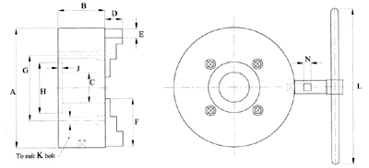

*Product  Code | SIZE | A | B | C | D | E | F | G | H | J | K | L | N | WEITHT IN KGS  (APPROX.)
5092-6 | 6" | 152 | 78 | 45 | 25 | 23.9 | 55 | 105 | 127 | 6 | M10 | 165 | 8 | 9.6
5092-8 | 8" | 203 | 93 | 50 | 32 | 30.1 | 80 | 110 | 85 | 6 | M10 | 215 | 10 | 18.1
5092-10 | 10" | 254 | 94 | 60 | 39 | 34.9 | 90 | 126 | 100 | 8 | M12 | 265 | 11 | 26.3
5092-12 | 12" | 305 | 101 | 75 | 45 | 38.1 | 105 | 140 | 160 | 10 | M12 | 340 | 12 | 39.7
5092-14 | 14" | 355 | 101 | 85 | 52 | 38.1 | 115 | 155 | 175 | 10 | M12 | 340 | 12 | 50.5
5092-16 | 16" | 406 | 107 | 100 | 54 | 44.5 | 125 | 175 | 200 | 10 | M16 | 420 | 13 | 68
5092-18 | 18" | 457 | 107 | 100 | 54 | 44.5 | 150 | 175 | 200 | 10 | M16 | 420 | 13 | 82

HEAVY DUTY 4 JAW INDEPENDENT CHUCKS
CSV Heavy Duty chucks refereed as HD, are suitable for normal working conditions. However thease chucks will stand well ahead in Quality, Load carrying capacity and Life if compared with other competitive brands available in the market. Where other brands of chucks fail to give service, csv chucks will give trouble free service for long period. The jaw-ways in body are of robust proportion which can withstand heavy loads. The diameter of screws is large enough to tolerate heavy cutting pressure and moreover large diameter of screws provide more contact area with threads of jaws. ACME threads of screws are very strong as the same have 29 degree taper. These do not break easily due to strength provided by large base of taper thread. Chucks from 160mm onward have , double type thrust bearings of robust proportions which provide great strength. Operating Key, Mounting Bolts & Inspection Report is provided with each chuck.
*Product  Code | SIZE | A | B | C | D | E | F | G | H | J | K | L | N | Wt. in Kgs.  Approx.
6093-80 | 80 | 82 | 45 | 20 | 20 | 12 | 32 | 60 | 70 | 4 | M6 | 90 | 5 | 2
6093-100 | 100 | 102 | 55 | 25.4 | 22 | 19 | 48 | 70 | 85 | 5 | M8 | 120 | 7 | 3
6093-125 | 125 | 125 | 55 | 32 | 22 | 19 | 48 | 80 | 100 | 5 | M8 | 140 | 7 | 4.5
6093-160 | 160 | 160 | 75 | 45 | 24 | 23.9 | 55 | 138 | 120 | 6 | M10 | 165 | 8 | 9
6093-200 | 200 | 200 | 87 | 50 | 32 | 29.9 | 75 | 100 | 80 | 6 | M10 | 215 | 10 | 15.5
6093-250 | 250 | 250 | 87 | 60 | 33 | 29.9 | 85 | 110 | 130 | 8 | M10 | 265 | 10 | 21.5
6093-305 | 305 | 305 | 95 | 75 | 45 | 34.9 | 100 | 140 | 160 | 10 | M12 | 340 | 12 | 36.5
6093-350 | 350 | 350 | 95 | 85 | 51 | 34.9 | 110 | 140 | 160 | 10 | M12 | 340 | 12 | 43
6093-400 | 400 | 400 | 105 | 100 | 60 | 40.7 | 125 | 175 | 200 | 12 | M16 | 420 | 13 | 64
6093-450 | 450 | 450 | 105 | 100 | 60 | 40.7 | 150 | 175 | 200 | 12 | M16 | 470 | 13 | 76.5
6093-500 | 500 | 510 | 115 | 110 | 66 | 47 | 170 | 235 | 260 | 12 | M20 | 520 | 14 | 113.5
6093-600 | 600 | 610 | 115 | 140 | 66 | 47 | 170 | 235 | 260 | 12 | M20 | 620 | 14 | 133.5

BIG BORE 4-JAW INDEPENDENT CHUCKS
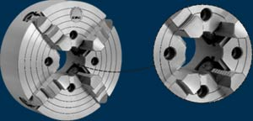
These 4-Jaw Independent Chucks have larger Bore than normal Chucks. These are suitable where machine is light and the Job demands larger Bore. Operating Key, Mounting Bolts, Allen Key, Tap & Inspection Report is provided with each chuck.
*Product  Code | SIZE | A | B | C | D | E | F | G | H | J | K | L | N | Wt. in Kgs.  Approx.
5094-12 | 12" | 305 | 101 | 100 | 45 | 38.1 | 105 | 185 | 160 | 10 | M12 | 340 | 12 | 37
5094-14 | 14" | 355 | 101 | 125 | 52 | 38.1 | 115 | 200 | 175 | 10 | M12 | 340 | 12 | 45.5
5094-16 | 16" | 406 | 107 | 150 | 54 | 44.5 | 125 | 230 | 200 | 10 | M16 | 420 | 13 | 60
5094-18 | 18" | 457 | 107 | 150 | 54 | 45.5 | 150 | 330 | 200 | 10 | M16 | 420 | 13 | 74

*Product  Code | SIZE  in mm | A | B | C | D | E | F | G | H | J | K | L | N | Wt. in Kgs.  Approx.
6094-305 | 305 | 305 | 101 | 100 | 45 | 34.9 | 100 | 185 | 160 | 10 | M12 | 340 | 12 | 34
6094-350 | 350 | 350 | 101 | 125 | 51 | 34.9 | 110 | 200 | 175 | 10 | M12 | 340 | 12 | 38
6094-400 | 400 | 400 | 107 | 150 | 60 | 40.7 | 125 | 230 | 200 | 10 | M16 | 420 | 13 | 56
6094-450 | 450 | 450 | 107 | 150 | 60 | 40.7 | 150 | 330 | 200 | 10 | M16 | 420 | 13 | 68.5

2-JAW SCREW OPERATED SELF CENTRING CHUCK
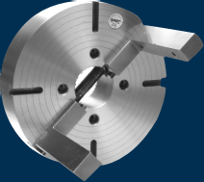
These are special 2-Jaw Self Centring Chucks but without scroll. This self centring mechanism is made with the help of one screw which moves both the jaws. These chucks usually have high height jaws with threaded holes. These jaws are kept soft so that machining or welding can be done on them. Special type of fixture can be mounted on the Jaws to suit special jobs. These fixtures are machined to make the same true. These chucks are not as accurate as scroll operated Self Centring Chucks, but these can tolerate heavy load. Operating Key, Mounting Bolts, Allen Key & Tap is provided with each Chuck.

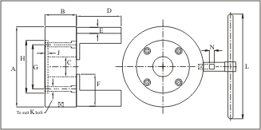

*Product  Code | SIZE | A | B | C | D | E | F | G | H | J | K | L | N | Wt. in Kgs.  Approx.
6096-160 | 160 | 160 | 93 | - | 90 | 34.9 | 55 | 138 | 120 | 5 | M10 | 285 | 12 | 16.0
6096-200 | 200 | 200 | 93 | - | 110 | 34.9 | 75 | 100 | 80 | 5 | M10 | 285 | 12 | 20.0
6096-250 | 250 | 250 | 101 | - | 130 | 40.7 | 85 | 110 | 130 | 8 | M12 | 320 | 13 | 28.0
6096-305 | 300 | 305 | 101 | 75 | 160 | 40.7 | 100 | 140 | 160 | 10 | M12 | 350 | 13 | 42.0
6096-350 | 350 | 355 | 101 | 85 | 185 | 40.7 | 110 | 155 | 175 | 10 | M12 | 350 | 13 | 53.0
6096-400 | 400 | 406 | 107 | 100 | 200 | 44.5 | 125 | 175 | 200 | 10 | M16 | 450 | 13 | 72.0

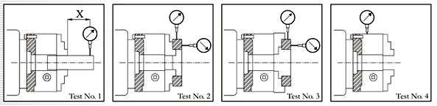
Test  No. | Test Applied | Over | Size of chuck  Upto and  Including |  | Permissible  Deviation  in mm
1 | Accuracy of Grip on Test Bar  (Using Master Pinion) |  | 160mm x=50 mm |  | 0.040
1 | Accuracy of Grip on Test Bar  (Using Master Pinion) | 160 mm | 250mm x=50 mm |  | 0.060
1 | Accuracy of Grip on Test Bar  (Using Master Pinion) | 250 mm | 315mm x=75 mm |  | 0.075
1 | Accuracy of Grip on Test Bar  (Using Any Pinion) |  | 160mm x=50 mm |  | 0.080
1 | Accuracy of Grip on Test Bar  (Using Any Pinion) | 160 mm | 250mm x=50 mm |  | 0.080
1 | Accuracy of Grip on Test Bar  (Using Any Pinion) | 250 mm | 315 mm x=75 mm |  | 0.100
2  &  3 | Accuracy of Grip on Test  Rings when gripped  internally or Externally  (Using Master Pinion) |  | 160 mm
2  &  3 |  | 160 mm | 250mm |  | 0.040
2  &  3 |  | 250 mm | 315 mm |  | 0.060
2  &  3 | Accuracy of Grip on Test  Rings on the Face of Ring |  | 160 mm |  | 0.025
2  &  3 | Accuracy of Grip on Test  Rings on the Face of Ring | 160 mm | 250mm |  | 0.030
2  &  3 | Accuracy of Grip on Test  Rings on the Face of Ring | 250 mm | 315 mm |  | 0.040
4 | Concentricity of Outside  Diameter |  | 160 mm |  | 0.030
4 | Concentricity of Outside  Diameter | 160 | 250mm |  | 0.040
4 | Concentricity of Outside  Diameter | 250 mm | 315 mm |  | 0.060

3-JAW & 4-JAW STANDARD & BEARING RACES CHUCKS

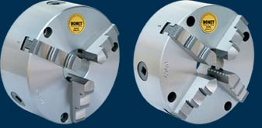
 | 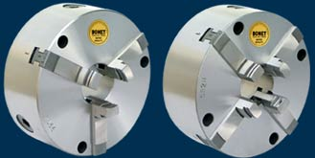
Standard Self Centring Chucks |  | **Bearing Races Self Centring Chucks
These chucks are available with 3 jaws and 4 jaws and are referred as STC-3 and STC-4 respectively. STC-3 chucks are most popular. STC-4 chucks are used when the job is square or to grip jobs having thin walls as holding pressure is divided on four sides. One set of reverse Jaws, Mounting Bolts, Operating Key and Inspection Report is provided with each chuck |  | These chucks are available with 3 jaws and 4 jaws and are referred as BRC-3 and BRC-4 respectively. The jaws are specially designed to grip machined or un-machined Bearing races. BRC-4 chucks are used to grip bearing races having thin walls as holding pressure is divided on six sides. One set of reverse Jaws, Mounting Bolts, Operating Key and Inspection Report is provided with each chuck
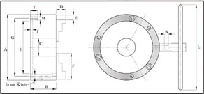
*Product  Code | Size  in mm | A | B | C | D | E | F | G | H | J | K/M | L | N | T | WEIGHT  IN KGS  (APPROX.)
 |  |  |  |  |  |  |  |  |  |  |  |  |  |  | 3 JAW | 4 JAW
5001-1003 | 100 | 103 | 52 | 26 | 17 | 15 | 37 | 89 | 76.2 | 3 | M6 | 175 | 8 | 12 | 3.2 | 3.3
5001-1603 | 160 | 160 | 70 | 42 | 24 | 20 | 65 | 140 | 125 | 6 | M10 | 200 | 10 | 20 | 9.2 | 9.5
5001-2003 | 200 | 200 | 78 | 55 | 29 | 22 | 80 | 176 | 160 | 7 | M10 | 285 | 12 | 22 | 15.5 | 16.1
5001-2503 | 250 | 250 | 86 | 76 | 35 | 29 | 95 | 224 | 200 | 7 | M12 | 315 | 13 | 25 | 26.2 | 27.5
5001-2703 | 270 | 270 | 86 | 90 | 35 | 29 | 95 | 245 | 220 | 7 | M12 | 315 | 13 | 25 | 29 | 30.2
5001-3153 | 315 | 315 | 88 | 105 | 42 | 32 | 109 | 286 | 260 | 7 | M12 | 350 | 14 | 25 | 40.5 | 42.3

3-JAW CRANKSHAFT GRINDER CHUCKS
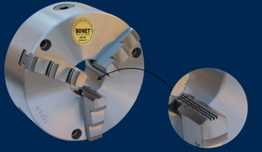
This chuck is available with 3 jaws only and is referred as CRC-3. This chuck is similar to Normal Standard Chuck. The only difference is that the gripping portion of jaws have serrations & rod of Operating key is longer. This is done to obtain maximum grip on crankshaft. One set of reverse Jaws, Mounting bolts, Operating Key and inspection report is provided with each chuck.

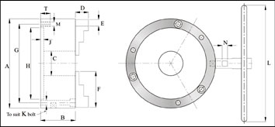

*Product  Code | Size  in mm | A | B | C | D | E | F | G | H | J | K/M | L | N | T | WEIGHT  IN KGS  (APPROX.)
 |  |  |  |  |  |  |  |  |  |  |  |  |  |  | 3 JAW
5005-1603 | 160 | 160 | 70 | 42 | 24 | 20 | 65 | 140 | 125 | 6 | M10 | 300 | 10 | 20 | 9.2
5005-2003 | 200 | 200 | 78 | 55 | 29 | 22 | 80 | 176 | 160 | 7 | M10 | 350 | 12 | 22 | 15.5
5005-2503 | 250 | 250 | 86 | 76 | 35 | 29 | 95 | 224 | 200 | 7 | M12 | 350 | 13 | 25 | 26.2
5005-2703 | 270 | 270 | 86 | 90 | 35 | 29 | 95 | 245 | 220 | 7 | M12 | 350 | 13 | 25 | 29
5005-3153 | 315 | 315 | 88 | 105 | 42 | 32 | 109 | 286 | 260 | 7 | M12 | 350 | 14 | 32 | 40.5

